***BDM-model parameters***

*allopatric speciation*

*parapatric speciation; including immigrants*

*No selection for local adaptation: no fitness difference*

*Selection for local adaptation: advantageous/beneficial & deleterious alleles*

*one-population scenario “start genotype”: ab*

*two-population scenario “start genotype”: Ab*

population size: N

**Production new species**

birth; b

birth incipient; bi

birth good; bg

mutation good to incipient; bg

mutation incipient to incipient; bi

**Extinction species**

extinction; µ

extinction good; µg

extinction incipient; µi

extinction/mutation good ?

extinction/mutation incipient ?

speciation completion rate: SCR

mutation incipient to good: SCR

**System characteristics**

speciation; u

mutation rate; (µ in boek)

average waiting time to speciation: t

waiting time to speciation: T

transition rate from state i to state j: Pij

migration; m

rate of fixation of deleterious alleles relative to that of neutral alleles: Kd

rate of fixation of advantageous alleles relative to that of neutral alleles: Ka

selection coefficient: s

**Novelties BDM-model**

**Two-locus, two-allele model**

**Fitness**

* (Only) two fitness levels
* Characterized by holey fitness landscapes

**Backward mutation**

* Only if ancestor good species is extinct
* Otherwise good species goes “back in time” to become an already existing species

**Mutation to dominance of incompatibility**

* Form of extinction, that can be included in the former good species and incipient species extinction
* Mutation leads to the presence of the two alleles that cause incompatibilities

**Incipient species characterized by including one of two mutations leading to new good species**

* Incipient stage brought back to genotype characteristics
* Still chance of mutations to incompatibility stage or backward mutation to ancestor

**Possibilities to build in more complex processes**

* Include parapatric speciation with parameter migration
* Include selection for local adaptation with differences in fitness of new alleles (advantage or disadvantage) with parameters Kd & Ka

**Possible differences in duration of speciation (t) and average waiting time to speciation (T)**

* Comparable in allopatric case, different in parapatric case
* For parapatric case, comparable T & t for two-population scenario, for one-population scenario T > t and for direct selection t decreases. A genetic barrier (to the neutral gene flow, immigrants or F1 hybrids have reduced fitness) does not affect t. A genetic barrier does not affect T in the two-population case, but T decreases in a one-population case.

**Model dynamics other models**

**1. PBD model simulation without pruning tree:**

* Starts with a single good or incipient species
* Determine rate R of all events: R = (λ1 + µ1) Ng + (λ2 + λ3 + µ2) Ni
* Determine time next event
* Determine probability of all events separately
* Determine event; adjust Ni & Ng
* Determine for each event in what species it occurs
* Negative integer stand for incipient species, positive integer for good species
* Store time of speciation initiation, label of parent, time of speciation completion & time of extinction

**2. Fisher-Wright model**

* Uses separate no-overlapping generations to implement replacements in population
* Uses constant population with changing “labels”

**3. Moran model**

* Each time step random individual chosen for reproduction and death, can be the same
* Uses constant population with changing “labels”

**4. Bateson-Dobzhansky-Muller Model**

* **Start with one incipient or good species, other individuals considered dead/non-existent**
* **Each individual has its label with genotype and incipient/good type**

**Bepaal mutatie en effect (incompatibility, Speciation completion, “birth” of incipient species from good species,**

**Bepaal tijd tot mutatie**

* **Aantal soorten is aantal genotypes??**
* **Begin populatie met 1 incipient/good species & 999 “dode/slapende” individuen**

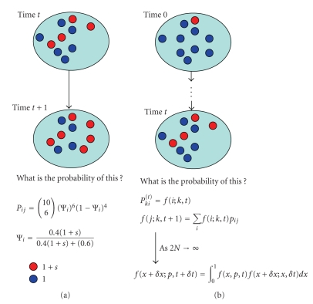

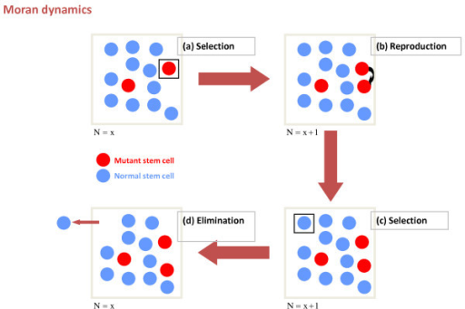

**Klad presentatie 27-09**

Bateson-Dobzhansky-Müller-model

Two locus, two allele model with two incompatible alleles at different loci

1. Initial ancestor population with fixed genotype small a & small b: aabb
2. After two mutations for each lineage two Intermediate derived descendants originated with fixed allele A in one and fixed allele B in the other descendant.

=> Could be characterized as incipient and good species

1. The hybrid with the incompatible alleles A and B. This incompatibility can be described as a reduced fitness component, for example fertility, viability or sexual attractiveness.

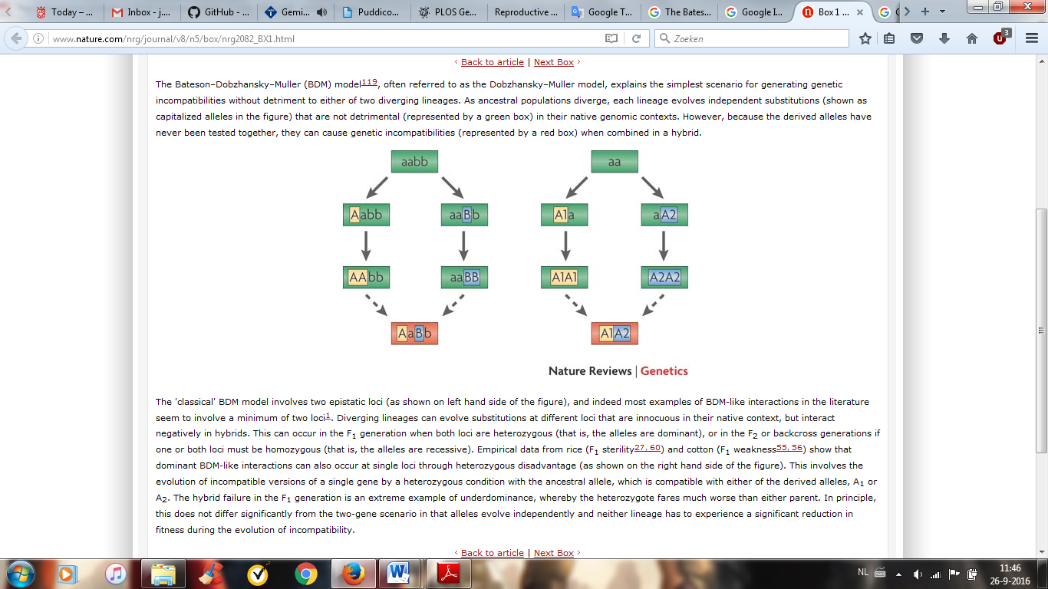

1. In a fitness landscape of the BDM the two different fitness levels, high fitness and low fitness, become visible. The incompatibility of alleles A and B can explain ridges of high-fitness genotypes, a so called “holey fitness landscape”. The model can evolve to strong reproductive isolation (RI) without crossing “fitness valleys”.

BB Bb bb

|  |  |  |
| --- | --- | --- |
| + | + | + |
| - | - | + |
| - | - | + |

aa

Aa

AA

1. Backward mutation: extinction and resurrection of the ancestor species
2. Research question:

What are the differences in phylogenies based on the protracted birth-death model (PBD) and the Bateson-Dobzhansky-Müller model (BDM)?

Using summary statistics: Gamma (γ) summary statistic (tippy γ>0 or stemmy γ <0) the normalized lineages through time (nLTT) summary statistic (the number of lineages in a phylogeny over time), tree size (number of tips in a phylogeny) and the Phylogenetic Diversity metric (PD, the sum of all branch lengths in the tree, divided by the number of branches).

1. Biological context: inviability of hybrids found in platy fish species Xiphophorus maculatus and swordtails X. Helleri and Drosophila species with lethality and female sterility in hybrids. How long does speciation take in the BDM model and is this comparable with the dynamics in the PBD model?
2. Start with allopatric population including backward mutation, but without migration, advantageous alleles or disadvantageous alleles.